**Project Report**

**Foodle:** A food cookbook and recommendations

**Team:** Yiwen Fang (yf2560) | Bohua Liu (bl2835) | Guoshiwen Han (gh2567) | Yiran Lin (yl4628)

**Contents**

1. Project Proposal 1

2. Clickable Prototype 3

3. Architecture and APIs 6

4. Project MVP 7

**1. Project Proposal**

**What does it do?**

Foodle is a web application for recipe searching and intake monitoring. Based on users’ body conditions and taste preference, this app will display various matching dishes with nutrition information and cooking instructions.

(1) Function 1: Verification

Without signing up, users are unable to use anything in Foodle. Token verification provided by Cognito. During signing up, users provide information like name, gender, phone number, height, weight, age, email, diet labels, etc. Then, Foodle automatically offers recipes based on Food and Recipe Search API for users to choose and confirm. Furthermore, it records users’ diet history and calculates total calories.

(2) Function 2: Recipe provider

Users input available ingredients, and Foodle provides a list of recipes that the user can cook.

(3) Function 3: Recommendation

Foodle recommends recipes based on the weighted frequency equation as described below.

(4) Function 4: Visualization

On the profile page, users’ information is listed, and their standard intake calories are visualized by means of vivid charts as well as their actual intake calories.

**Why is it innovative or interesting?**

(1) Users are unable to make use of Foodle’s services until they sign in or sign up. Identity is verified by means of AWS Cognito, and user information is recorded in the signing up process through AWS Lex.

(2) Foodle furnishes searching service with parameters like cuisine, diet label, ingredients, exclude ingredients, etc. And users are capable of modifying their information like name, gender, age, phone number, email, height, weight, dislike, some of which will be used to calculate BMR. BMR is short for basal metabolic rate, which is the amount of energy expended per day at rest, and will be used to visualize through charts.

(3) For **recommendation**, the recommended recipes will be presented on the search page based on their weighted frequency in descending order. WF makes Foodle personalize with the parameters, which is also tuned by the global variable. And both parameters are weighted with a reasonable sum consisting of the specific user-recipe pair frequency and the recommended frequency parameter, from over 1,000 users’ data. The function mentioned above is accomplished by a modified Bayes formula, of which we make some adjustments to accommodate Foodle’s circumstance. The modified is represented as follows:

$$Weighted Frequency \left(WF\right)=\frac{f}{f+t}F+\frac{t}{f+t}A$$

where f is the frequency of specific recipe for all users, t is the smallest frequency necessary to be rated as top popular recipes, f is the frequency of a specific recipe for a specific user, A is the mean frequency for all recipes.

**If it needs data what data would you use?**

(1) User data features (over 1,000 users)

* User’s username and password: for Cognito validation and security
* User’s gender, age, weight, and height: for calculating BMR
* User’s email address: for sending dish information after a user select a dish
* User’s preference: for personalizing recipe searching process
* User’s phone number

(2) Recipe/Dish data features (up to thousands of recipes)

* Recipe’s nutrition information including calories, protein, vitamin C, fiber, sugar, fat, carbohydrates, sodium: for generating one bar chart and two pie charts
* Recipe’s image URL and title: for displaying on the search page and profile page
* Recipe’s cooking instructions: for teaching users how to cook a selected dish

(3) Validation data features

The user id and token: for security purpose and Cognito such that users have to login before they can use any functions of our application

**What are some existing similar works?**

Overall, our Foodle application will realize the shortages/disadvantages of similar platforms while retaining the main functions of their core capabilities. It would be a marvelous platform to help users choose recipes they prefer.

|  |  |  |
| --- | --- | --- |
|  | **Advantages** | **Disadvantages** |
| **MasterCook**  https://lh5.googleusercontent.com/laB_Glg7eJ-YGph9lSUGE47qsBe7ZrJreo66BSF5HzxC8tPpcWY4JzvwvHE7N_2pO47RXc2SKnQMcw4ht3YnIDC0ZFotDmoc1KrYgb9y8u6MJD9YPRkMcpWmZ6scnA_ryaQAMCqU | (1) Recipes can be transferred from Desktop App to Mobile Apps.  (2) Provide both scaling recipes and recipe rating functions. | (1) Users cannot search the internet for recipes.  (2) There is no email for recipe confirmation.  (3) MasterCook does not provide a decent recommendation mechanism based on big data. |
| **Living Cookbook**  **https://lh4.googleusercontent.com/0vRoG90xg61KtItSb6pcndIGbzt3RF2kJCL_Bw8Y0GSFJoqwb0mieKD6qMYo3rLWI-9tZMOvajuDCogqnIamF8P7YpIeNZTir4S-_5i93z22kcIV33fXK46i8aTzIWlZSJYTBewx** | (1) Living Cookbook provides One-Click Capture of Internet Recipes from Multiple Sites into Software Format.  (2) Support scanning printed recipes into the software. | (1) The recipes are not updated regularly. The platform itself does not support live recipe feed.  (2) No visualization chart to help users keep a lookout over their body condition. |
| **Spoonacula**  https://lh3.googleusercontent.com/vS5p90gugLEzz4M-iUxhNFH6GppyhMUEGOVBwwHNrHE9MJxF9DZlDSpg9SaQuh3ADsftrgRA4ws12TgdgZQcHpxHfswZa-BToRXx9LA3tp9YLFedz5kksxjOhu_l5U82o5dDX3uX | (1) Provide recipe information, especially for nutritions.  (2) Search recipe in various ways, such as dish names and ingredients. | Only provide recipe searching functionality so that it cannot personalize information for a single user. |
| **MyFitnessPal**  **https://lh6.googleusercontent.com/rVJsWy87PcarApvmmc6U8aiwvOGY_JlbsprsMVUg3w5pBxmov6sKiX1Mm_h5ihED-YBxtMrppGiWmEgFjxti_idfW6KcxIdjOzsycV3-Z-joQTYlxBZOtc1aiI-CSPy5PICN2XyX** | (1) Tracker both diet and exercise.  (2) Show nutrition information for selected food. | (1) Cannot provide recipes based on users’ preferences.  (2) Can’t teach users’ how to cook a particular dish. |

**2. Clickable Prototype**

Note: We have changed our final web application which has completely different prototypes as we designed/submitted at the beginning of the project. Therefore, we use the current screenshots to replace the previously submitted clickable prototype.

**Key screenshots**

Home Page - One



Home Page - Two

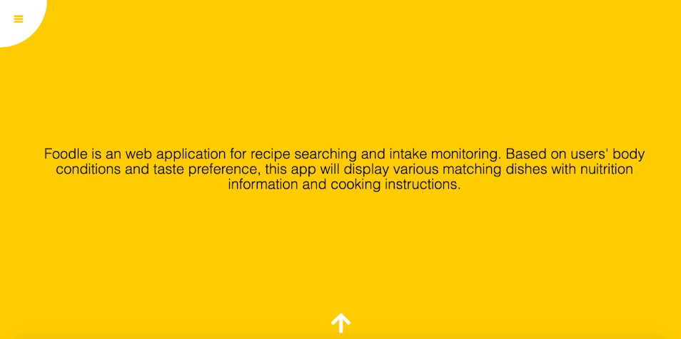

Account Page - Sign in container

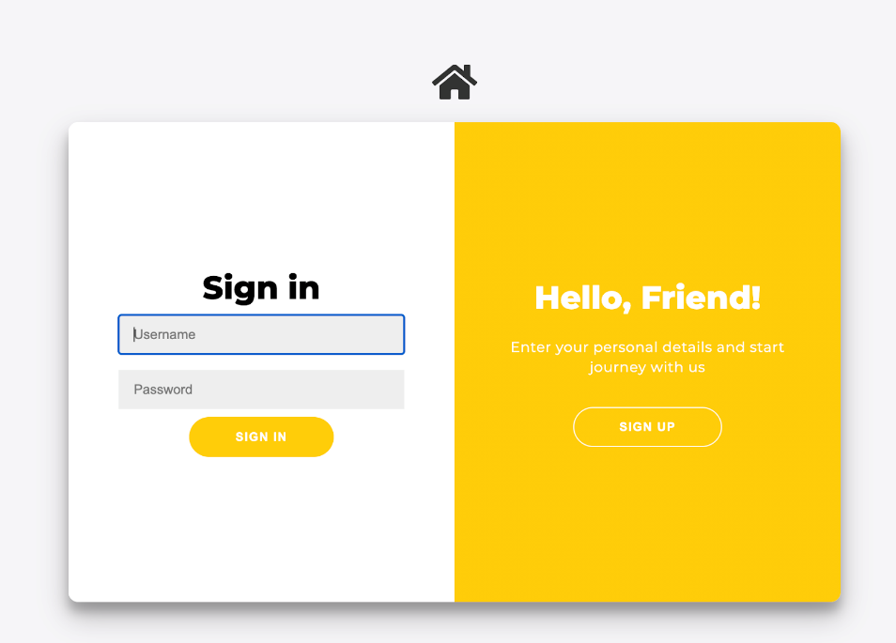

Account Page - Sign up container

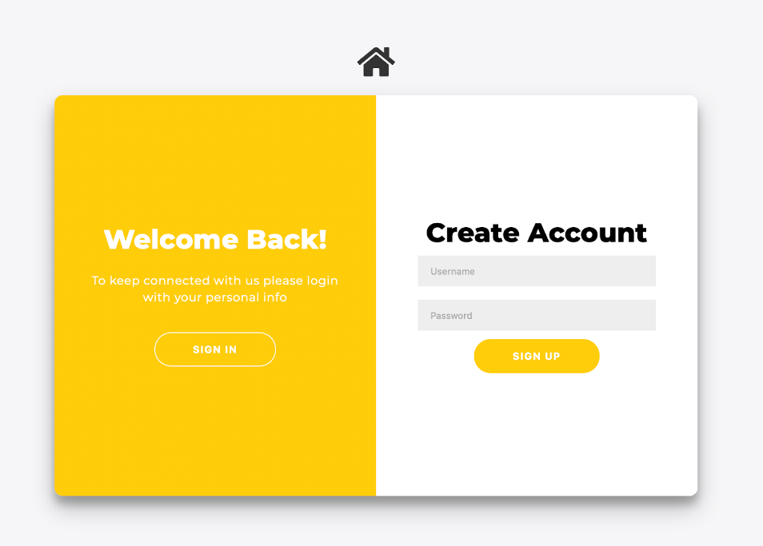

Lex Page - Fill user’s profile information

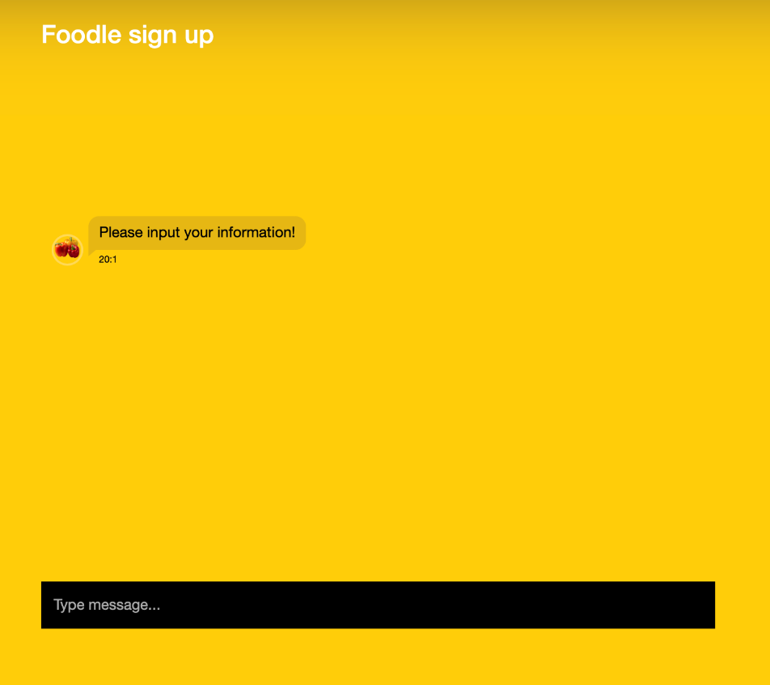

Search Page - Get recipe by personalized parameters

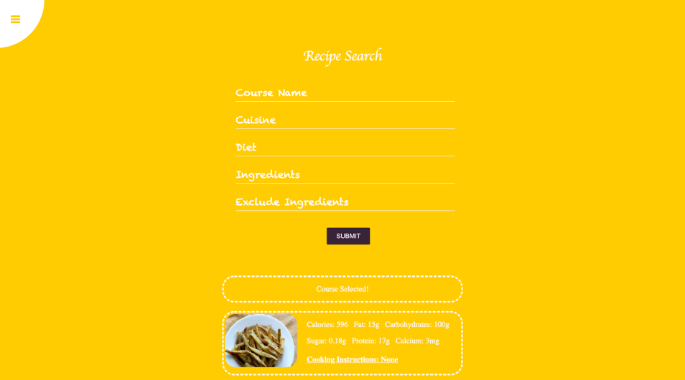

Profile Page - Display profile information and charts

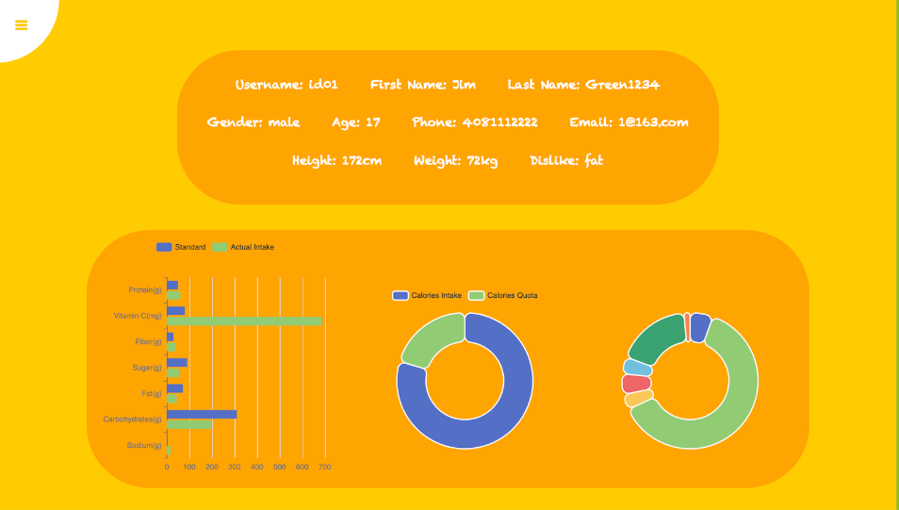

Profile Page - Edit profile information, list selected recipes for today, list top recommended and personalized recipes

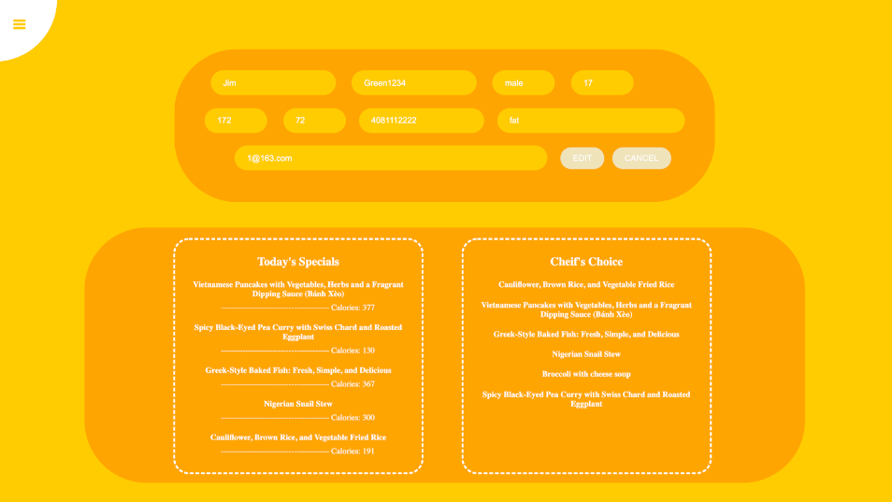

**3. Architecture and APIs**

**Architecture**

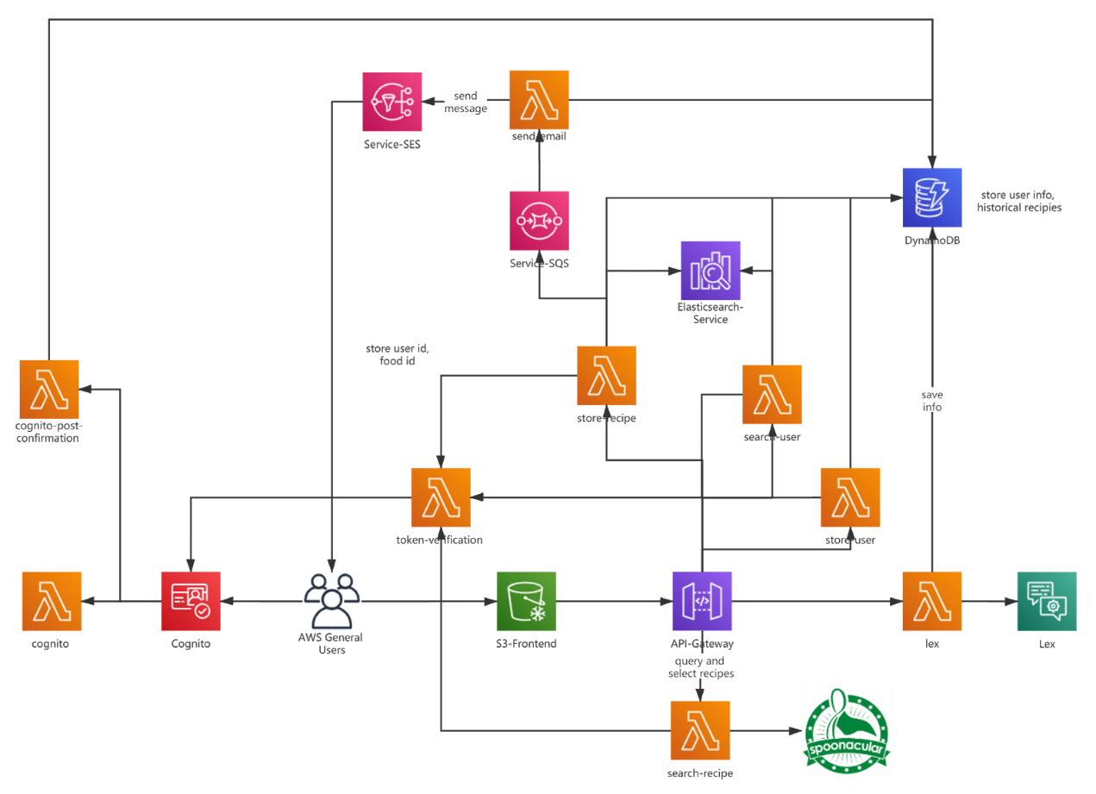

**API list**

* 9 Lambda functions
  + Cognito/cognito-post-confirmation/token-verification: access control for Cognito
  + Store/search-user: save or search user information in DynamoDB/Elasticsearch
  + Store/search-recipe: save users’ recipe frequencies in Elasticsearch and update current recipes in DynamoDB or query and select recipes through spoonacular API
  + Lex: interact with Lex to let users input information
  + Send-email: inform users when they confirm the recipes by email
* Lex: Collect a user’s profile information
* SQS: Receives messages from store-recipe Lambda Function and provides guarantees that every recipe that users have confirmed will not be lost
* SES: If a recipe is selected, an email will be sent to the user.
* Spoonacular API: Query and select recipes as well as their information.

**4. Project MVP**

**Demo slide**

